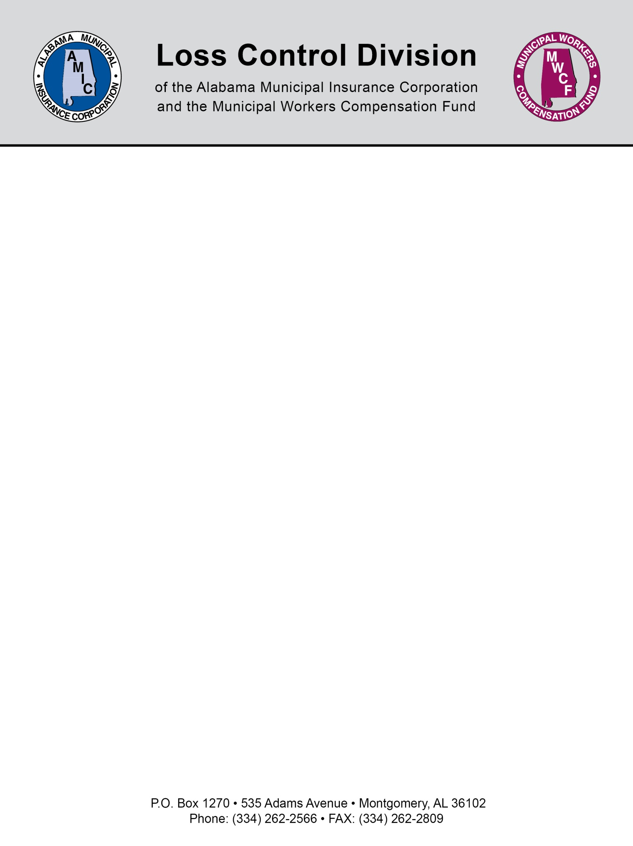

Coverage for Passengers in Insured Automobiles?

Municipalities are not responsible for injuries from auto accidents for which they are not at fault. This is addressed in the State guest passenger code. (Section 32-1-2 Liability for injury or death of guest.)

If the municipality is responsible and negligent in causing injuries to a passenger in an automobile then the applicable limits of liability will apply.

If a municipality or utility desires medical payments coverage it must be purchased by paying an additional premium per vehicle with a maximum limit of $5,000 per passenger.

Section 32-1-2

Liability for injury or death of guest.
The owner, operator or person responsible for the operation of a motor vehicle shall not be liable for loss or damage arising from injuries to or death of a guest while being transported without payment therefor in or upon said motor vehicle, resulting from the operation thereof, unless such injuries or death are caused by the willful or wanton misconduct of such operator, owner or person responsible for the operation of said motor vehicle.

(Acts 1935, No. 442, p. 918; Code 1940, T. 36, §95.)

NOTE: This document is not intended to be legal advice. It does not identify all the issues surrounding the particular topic. Public agencies are encouraged to review their procedures with an expert or an attorney who is knowledgeable about the topic. Reliance on this information is at the sole risk of the user.

Revised 8/2013

